Aajonus’ stories, anecdotes,

experiments, studies, testimonials, …

Document author: Rom
Version: 0.1

A collection of many stories from Aajonus, about the miraculous healing and benefits that can be afforded by raw foods and his Primal Diet.
These stories may concern himself, his clients, experiments, observations of tribesmen, …
More will be added.
Latest version can always be found here:
https://healthfully.ai/receipts

About his son Jeff

The first part of Aajonus’ first book “We Want To Live” tells the story of how he saved his son Jeff, who was in a coma after his car had fallen off a 70 foot cliff going 60 miles an hour, sending him through the windshield, out the passenger window, then back into the car. The hospital pulled glass out of his head for a year. At the hospital, Aajonus was swapping his son’s drugs with raw foods, and made sure they would avoid certain procedures that he deemed could be lethal.
(Full interview with Jeff: https://healthfully.ai/article/jeff-interview)

The oyster fisherman who grew an entirely new set of teeth at 90 years old

A: That one man in Thailand, 90 year old man who grew a whole set of teeth at 90 years old.....documented, documented.
Q: He has three teeth came back?
A: All of his teeth grew back. All....every tooth grew back at 90 years old.
Q: What did he do?
A: He was an oyster fisherman so he ate oysters everyday.
Source: Q&A 2013_06_16
https://healthfully.ai/qa/2013_06_16?pos=43367&keywords=oyster

Pem Wall, senior martial artist

His testimony can be viewed here:
https://youtu.be/rOAdrR8PPvs
Pem Wal, senior martial artist who still participates in karate competitions, show through a chart monitoring his heart rate over months while doing rope jumps, that it is going down every month.

Jeff Slay

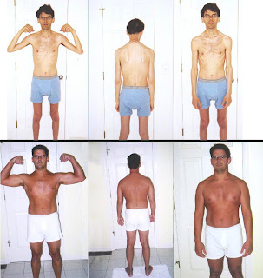

Jeff Slay was losing weight uncontrollably, and no diet could help him regain a normal weight.
After going on the Primal Diet, he gained athletic weight without doing any sports.

Mel Gibson

A: Mel Gibson was the only one who came out and said I eat raw meat on the David Letterman show. Nobody carried him after that, except for you know, the trash papers, the tabloids. They were always mentioning that he was eating raw meat.
Q: What’s going on with him, he’s not looking too good though?
A: Well he got off the diet a year ago. And started drinking again.
https://healthfully.ai/qa/2007_02_18?pos=38086&keywords=hollywood
News article:
https://www.cinema.com/news/item/2533/mel-gibsons-raw-meat-diet-causes-concern.phtml

Aajonus also claimed he got a mutual to convince the Dalai Lama to eat meat again, and that he had many high-profile clients such as Olympic athletes whose name he didn’t give to avoid them getting into trouble.

97% survival rate for his clients with cancer

A: Fourteen years ago when my book first came out, it was 13 years, 95 percent, and that was validated by the neuroscientist from Columbia University, Elnora Van Winkle. She met with 232 that survived out of the 242 patients, and she interviewed them after up to 12 years being on the diet. They were all cancer symptom-free. I didn't want them to have X-rays, only ultrasound, so some of them could not be proved. But Elnora Van Winkle, she validated it and wrote it. I still think you can find that report on the Internet somewhere. Now I'm up to only losing about three per hundred. So that means 97 percent. It means 97 out of a 100 kick the cancer. Probably I've worked with 1,200 people with cancer.

Woman who regrew her finger

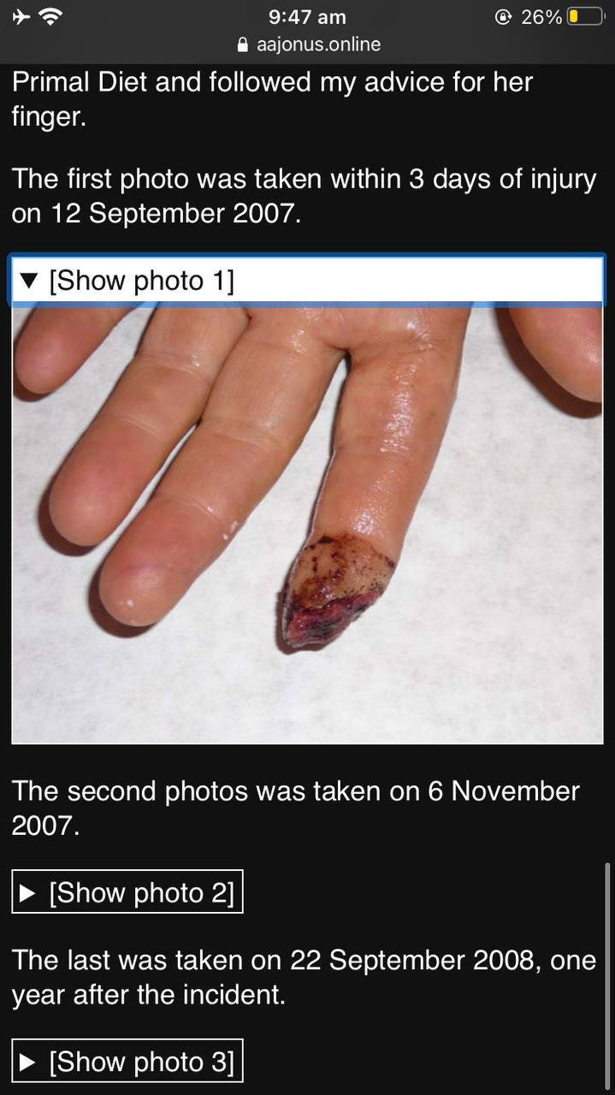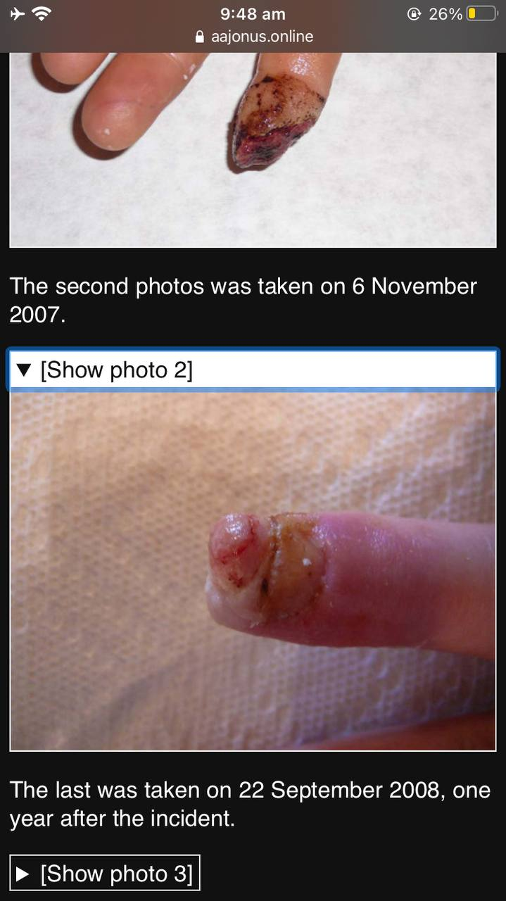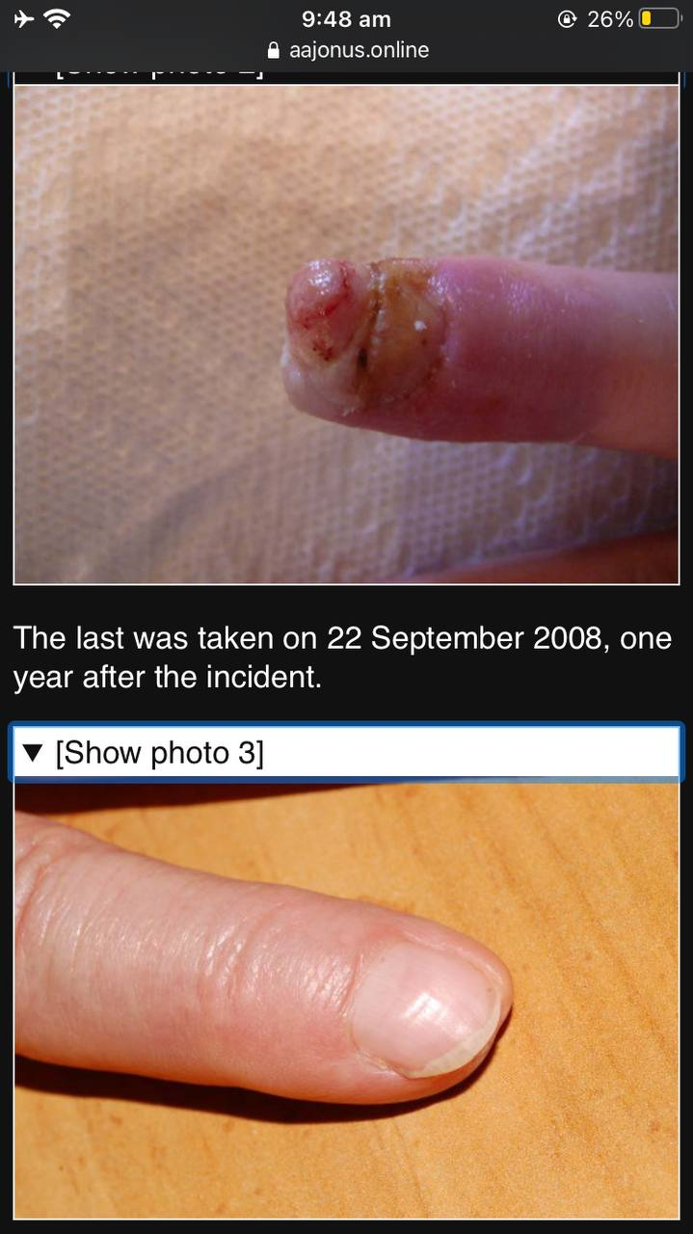

Walker Kehrer

Q: What did you do to for sports or running long distances?
A: Again, you want nutrients. Do you remember the boy who was a part of the raw milk issue in 1999 to 2000?
Q: Yeah.
A: There was a little eight year old boy named Walker that ah...he was eight years old and he had asthma. So he was a very sickly, weak little child and he got up there and he said, 'I have to have my raw milk, it's the only thing that makes me feel good'. He is now the number two high school tennis champion for the whole United States. In all of the high schools in all of the United States, he is number two.
Q: He's not number one?
A: No. He just drinks a little water in the formula, in the sport formula. What you do is you take about a cup to a cup and a half of tomato a cup and a half to two cups of cucumber puree, so you're pureeing the cucumber… the tomato. You peel the cucumber, always peel the cucumber, that's cellulose you can't digest; it'll interfere with digestion, most of the time it's got some kind of petroleum wax on it even if organic. If you're growing them yourself, take the peel and juice them with your juicer; don't throw them away that way but otherwise peel them, get rid of the peel. You chop up that, blend it all together with three to four tablespoons of coconut cream, three to four tablespoons of dairy cream, one egg, a tablespoon of vinegar, tablespoon of lemon juice and four tablespoons of honey. I've had tennis players that play fiver hours with that one quart of fluid and their competitors are drinking three to four quarts, a whole gallon of water in that five hours.
Q: If i exercise for 5 hours, all I need to do is drink one of those...
A: Right and I have them put a..I've..I've left that out. I have them add a cup of water to that mixture. If you're doing a high sport you add a cup of water to that because you will need a little bit of water in there.
Q: Same hydration formula as the book?
A: No. ...it's different - the way I have it in there - and I've refined it, you know I've refined it to this point, pardon?
https://healthfully.ai/qa/2008_08_24?pos=42969&keywords=eight%20boy

Drug addict and alcoholic’s body in excellent condition, clear addict, because he was protected by his fat, which he then lost effortlessly on the diet

A: I had a man come to me who had very thick skin and he looked like he’d been a drug addict and an alcoholic for at least 25 years. When I took his eyes, his irises, and read them - you know his body was 55, 56 years old I don’t recall ; he had been through a lot, and you could see it in his skin but inside he was like a 30 year old man, pretty clean, and he was only like 15, 20 pounds overweight. And I said to him it doesn’t make any sense I can see you’ve been a drug addict and an alcoholic for at least 25 years, he said yah 30 years. And I said it doesn’t make any sense because your insides, your glands and your organs are relatively clean for what you’ve done to yourself. Your skin didn’t escape it but your internal body did. And I said, you know, you’re only minorly overweight, and he said well before I went on your diet four months ago I was 300 pounds. And he had been 300 pounds on donuts and garbage, you know, while he used drugs and was in a motorcycle gang for almost 30 years. So even that fat protected him. It isn’t a fat that is easy to carry, it can be exhausting when the heat gets high, and high blood pressure, and all kinds of other things. And if you’re fat you better have high blood pressure because you’ve got fat pushing on your veins and arteries, you’ve better have high blood pressure to make sure they’re expanded. And you better have high cholesterol levels because you need to be cleaning it out all the time to move some of that stuff. So the difference between the ideal fats to have in the body and the cooked fats are, if you have a lot of fats from the cooked fats you’ll be big. I’m fat but you can’t tell I’m fat, 26 percent body fat. You’re probably 12 percent, 13. I’m double what you are but I don’t look it, do I. That’s because all the fat I eat is small. Very small molecules. So I can be lighter. I can move, have more flexibility, I’m lighter. I get in the heat and it doesn’t bother me. A person who is huge and overweight doesn’t have an easy time with the heat. Ok? Cholesterol levels very very important. Just remember that half the cholesterol, when you’re on this diet, half the cholesterol in your blood is LDL leaving the body.
Source: Q&A 2007_02_18
https://healthfully.ai/qa/2007_02_18?pos=74489&keywords=overweight

Man who averted a heart attack with a shot of raw vinegar

Q: Yeah I was doing the same thing, I was eating all fruits all day. Four months ago I had a heart attack. It was amazing because I was able to crawl and I knew where the vinegar was and I had two shots and one big fat ice cream. and like two hours later I was ok. Is that a detox?
A: Well, what you did was thin the blood from a clot. Usually a heart attack is when you get too much acidity or too much compound in the blood that causes a charley horse in the heart. you know a charley horse in the leg? You get a charley horse in the leg. The more you fight it the worse it gets. Heart attack is the same way. You have to completely relax, you have to breathe slowly. Inhale and exhale slowly and not not too deeply. If you inhale to deeply your going to cause the cramp to get worse. It's a matter of just staying focused. Do not breath fast and panic. That's where you have your tension remain. Then you're likely to black out. If you don't black out soon enough, your body isn't going to relax - it's going to stay in that tightness. As I said, uric acid builds up in that area; it will maintain the charley horse. So you need to relax right away. You sit down, lie down and you start very slowly breathing, you breath deeply until you feel it tighten and then you just exhale again slowly and you'll come out of it. I've had three hundred heart attacks from fifteen and a half to twenty two because I got diabetes and angina pectoris after my third polio vaccine.
https://healthfully.ai/qa/2008_12_14?pos=90405&keywords=shot%20vinegar

Obese woman who craved ice cream

A woman who was obese was constantly craving ice cream. Aajonus told her to have it raw, so she had it every day, for a month, and one day, stopped craving it entirely.
Despite eating so much fat, she had lost all her extra weight.

Man who cleared 90% of his extremely toxic mercury-ladden gut by eating tremendous amounts of raw unsalted cheese

Aajonus: I had this one fellow. The only problem, real problems that I have are with patients who have been skinny a long time in their lives. And I mean bird legs and bird thin all their life. They didn’t have any fat to store poisons. They went into the cells. So all their cells are terribly contaminated. Those are my worst patients. They are always in pain, they are always suffering, they are always in fatigue. When they reach that straw in their life it breaks their back of health. It sometimes takes 10 years, eleven years before they are at a normal plane. So it is difficult.
Now I had one fellow that came to me two years ago that was in that shape. He was calling me all the time. Those people do. I only have four of them right now. Two of them now are pretty well. Two of them call me pretty regularly. One has been on for three years and one two years. He came to see me in Chicago. He was grey, he was grey, I mean grey, not any pink in his skin. Nothing, he was grey. He was dark grey around here almost charcoal, like a raccoon.
Audience: What causes that?
Aajonus: That is metal poisoning, especially tin and mercury from injections and aluminum.
It is a good thing because they are trying to throw it out, and they throw it into the skin. 90 percent of the toxins are supposed to leave thorough the skin. In those people they have so many toxins it is going to go layer after layer after layer because it is deep in their tissue. There are a lot of people that I have seen where the toxins are not in the cells. They are out in the serums and outside the cell tattooed on the cell wall (not clear), so there is not as much functionality. But there is less pain and suffering in those people.
So this fellow came in the door and it was only 2 years and he was pink. So he was still a little grey here but he didn’t look like a raccoon any more. He was still smiling and happy, and this guy didn’t smile any time that I had seen him in the last two years or over the phone with him, nothing happy about him. But all of a sudden about 4 months he stopped calling me. I saw him 7 months ago when I was in Chicago. And I saw him last weekend, last week.
So I said O.K., you are not from this planet, right? Because in his intestinal tract, if you look at an iris, you’ve got the outer edge, you have got the pupil and around the pupil you are going to find this (not clear) that is the intestinal tract. His intestinal track was completely black. You could not tell (not clear) his intestinal tract; dark black spokes coming out from that in his pupil. That’s how much mercury and heavy metals he had in his intestines.
He was one of those skinny, skinny individuals that absorbed all those poisons and couldn’t throw them off because he had no fat to throw them off. So here he walked up, I photographed his eyes. I can see his entire digestive tract. 90 percent of the metal is gone. And he looks it. And I said What planet are you from? This isn’t natural or normal. He said I’m am doing better. I’m feeling good and he said I don’t see the difference but I feel the difference, I feel happy now, I feel energy. He went from bone thin like Jim was and a lot of other people, several other people who are here, bone thin, thinner than he. So he was big, his waist... he probably went from a..., he is about 6 feet 2 inches. He probably went from a 31 waist to 42. But he was strong, he had red skin, not all grey except around the eyes. It was just like a miracle. I’ve seen that a few times. But the people were not honest with me.
I said O.K., I want you to tell me what you eat. Take me through a day. He said I am going to be honest. I have been eating maybe 10 times more [raw unsalted] cheese than you told me. I said I gave you a minimum. I don’t care if you eat 10 pounds a day. I just want you to eat a minimum of a little cube of cheese, of a half a teaspoon every 15 minutes. He wouldn’t stop eating it, he just kept eating and eating and eating it and going through a pound, a pound and a half a day.
I tell people, that’s what vacuums. It absorbs the poisons out of the stomach and intestines and in 7 months he did that. You have to understand when I give you something, it is a minimum not a maximum, it’s a minimum. So pig out on the cheese if you have intestinal poisoning and you want to get rid of metal poisoning faster. Get fat for a while on cheese. Cheese will make you fat. You don’t digest it - the raw cheese - you won’t digest but it will allow you to utilize all your other foods to completely build and detox and heal, while the cheese goes through and does the main detoxification. So you are able to use all those foods that I tell you to eat. And I tell everybody to eat a lot with a lot of butter. So if you want to move fast through your poisons, do it. Lots of cheese.
Audience: One pound of cheese a day?
Aajonus: He is 6 feet 2 inches tall. You may want to eat 1/2 a pound of cheese a day.
Audience: With butter?
Aajonus: I had him first thing in the morning, I had him eat a little butter and several times a day, like once an hour he had a little bit of butter with so much cheese just so you don’t get too dry from it.

Woman who grew back her breast consumed by breast cancer

A: Now, I will experiment with some of my advanced cancer patients when they come to me. So, I had this one woman who had the same thing like that, but around her breast. It was half-gone. Now, I saw it yesterday and it was starting to grow back and the actual breast – first time I’ve seen a breast starting to grow back that was already collapsing from the body breaking down the cancers in there and dissolving it. So, I told her I’m used to people losing a breast naturally – so, they don’t lose all their lymphatic glands around them and it keeps them from having lung cancer. But, her breast actually started growing back. But, what started it was: I told her to start packing it with cheese.
G: Huh.
A: Taking a little cheese and milk and mashing it, getting it into a paste and put the cheese over it. Stopped all of the bleeding, stopped all that – the deterioration and started a healing effect. So, that doesn’t mean that she doesn’t have trouble later because she still has to get rid of the dead cells that make up the tumor. She still has some hardened tumor over here. All the tumor up here is all gone – it’s just soft and breast again. Now, there’s just a little bit down here. So, she stopped it from secreting. Now, it may go inside her or grow down this way – the cancer movement. And I warned her that that might happen. But, she just panicked.
So, this was just a quick fix so she wouldn’t run to the doctor and have her whole breast cut off and all her lymph glands and all of that. She was on the diet about six years.
G: Hmm.
A: And that breast and the tumor should have been absolute gargantuan, according to the medical profession, but each year it’s been getting softer and smaller. So, she’s been (Inaudible). But, when it’s been leaking and bleeding a lot – and that’s a sign that the cancer cells are actually dying – they contain like a solvent product that dissolves the dead cells – you only have one cancer cell around 50 to 200 dead cells – it’s isolated. But, you do have blood and lymph and neurological circulation in a malignant tumor. Not in a benign tumor – no circulation in a benign tumor. It’s a dead substance – you’re not going to eliminate it easily. But, when you have all the circulations into it you can dissolve a tumor – you can restore the body to a working, functional, living system again. When you have a benign tumor and stop living the whole area is completely dead. So, when that cancer cells begins dying and sending out that solvent to dissolve all those dead cells the serum has got to go somewhere. You don’t want it to go inside – you want it to come out, through of the skin. And it’s going to damage skin – it’s going to buckle it, it’s going to cause it to be sore and other things – but, you will discharge it that way. But, I was very happy with the process. But, I let her know that, that was a quick fix. If it seeps again, enjoy the seep – that’s the cancer cells dissolving all those dead cells that make up 90% of the tumor.
https://healthfully.ai/qa/2012_10_14?pos=108868&keywords=breast%20grow

Detoxification fluids burning holes in fabric

https://healthfully.ai/qa/2000_03_26?pos=16387&keywords=hole%20underwear
A: Correct, right. Now I have known women who start on the diet they start detoxing heavily out that canal and they will actually burn holes in their underwear from it.
G: Wow.
A: That is how bad it is. One woman I have on the diet right now that went on to it – she is discharging brown and green fluids and they are just tearing her labia up. It burns and there is swelling. This is from pretty toxic stuff – she has cancer.

Woman who rejuvenated her skin, from wrinkly, grey and dry, to vibrant and young

Q: Hi, talk to us about skin wrinkles
Well I’ve talked about that also in the, in my newsletter, bone marrow helps you..... sperm and ovum. Those are your best bets for it, Primal Facial ® Body Care Cream is also helpful. For most people that I’ve seen, the quickest is bone marrow. The oily bone marrow.
Yeah. Rub it gently into the wrinkle. Anybody knows Erica, at Rawsome? Erica was one of the people that never gained the weight that I wanted her to gain. To get rid of her dry skin - she was excessively dry, lots of wrinkles, lots of dry skin - she did enough to get her whole face lubricated. Remember that the most toxins you have, the metalic toxins, are in the brain. So when they leave out of the mouth, the gums, the tongue, the salivary glands, they pull all the fats out of the face. That’s why all tribes, all people wrinkle in the face first. Because all the contaminants in the brain dump out them out. So eating enough to keep the skin from wrinkling and relipidizing the skin fo the face, usually takes a tremendous amount of weight, 25 pounds overweight, to do that. So I started experimenting with bone marrow, so she agreed to do it, and within two and a half months of putting the bone marrow on her face two times a week, 80% of the wrinkles went away and 80% of the dryness. And she had been, I would say, anywhere from let’s say 70% on the diet for about six years. So she started doing that bone marrow on her face, big difference - huge difference. She brags about doing it. Best she ever had. because you always see that dry wrinkled, crinkled face, the rest of the body was pretty good.
Pardon? Well she does it probably three days a week, you can do it every day, you know, if you have the bone marrow.
It depends upon the skin. Yeah, if I put it on thickly it may take five or six hours to absorb, if I put it on thinly it’ll be absorbed in about twenty or thirty minutes. Especially if I rub it in gently.
https://healthfully.ai/qa/2009_02_22?pos=33487&keywords=she%20wrinkle

Aajonus’ champion athletes, more performant by drinking less water

While their opponents were drinking a gallon of water, tiring themselves, the tennis players on Aajonus’ diet were drinking a quart or two only of his “sports formula”, where the hydration is provided by raw foods rich in water, which have a higher concentration of nutrients bound to the water.

A: Well I have my athletes, a lot of tennis players on the diet. I give them a formula of 2 cups of cucumber juice, 1 cup of pureed tomato, teaspoon of vinegar, 3-4 tablespoons of honey, 3 tablespoons of coconut cream, tablespoons of dairy cream and that’s the mixture. They will drink that, just a little sip at a time and let me tell you, powerful players
Person: I tried that this month but I was gulping it so
A: You don’t gulp it, you sip it
Person: Just like the water
A: Yep. It was something I came up with recently because I started getting more athletes. For some of the people who are overweight and most of my tennis players are overweight. I’ve got one girl in Canada who’s six foot tall and weighs about 210 pounds and can you imagine a big girl like that is all over that court like you wouldn’t believe. In one year she’s become a champion. She’s 31 years old. I’ve got a 16 year old who’s also very stocky and big and she’s number 2
Person: And they don’t drink water
Source: Q&A 2007_08_19
https://healthfully.ai/qa/2007_08_19?pos=39570&keywords=overweight

Healing fibromyalgia by becoming overweight on raw foods

A: That is good. That is good. One woman who was chronically in fibromyalgia for 13 years. She was in bad shape and finally she was really overweight this time. All of her conditions, all of her irises had improved triple what she had done before. The body puts toxins in fat. If you don't have that fat, it is going to go into your cells and cause more damage, cause more disease. When you've got excess fat, lots of excess, the body just dumps in there.
Q: So, once you get rid of it, will the fat go away too?
A: Yep, toxins go with the fat.
Source: Q&A 2011_08_22
https://healthfully.ai/qa/2011_08_22?pos=85147&keywords=overweight

Vomit containing several times the lethal dose of poison

Aajonus had a client who worked in jewelry, without a mask, and got severe poisoning from it.

I had a cancer patient that was vomiting so much, I wanted to know why she was vomiting like 8 to 10 times a day and this was going for on 2 and a half months. And I convinced her to gain 30 pounds and I wanted her to go up to 45. Anyone with cancer, I want to go up as high as possible because if you go through this vomiting spell getting rid of the chemical that's caused the cancer. Sometimes it can be so debilitating they'll lose too much weight and then they'll never recover. She didn't gain as much weight as I wanted her to gain and she was vomiting pretty badly, having diarrhea also, and I sent just 4 ounces of vomit, just 4 ounces that came out of one vomit. all of it was only 4 ounces and I sent it to the lab. The chief of the lab called me and said "someone is poisoning your patient". I said, "What do you mean?" And he said "she has 3000 times the lethal dose of thallium in that 4 ounces of vomit". 3000 times the amount that can kill a human was in that one 4 ounces of vomit.
https://healthfully.ai/qa/2006_12_17?pos=36971&keywords=lab%20poison

Woman who healed from 63 tumors

“Take a look at owanza in the book: 63 tumors; 16 in her liver; 30 in her spine; four in her uterus the size of her fist which is about half the size of mine – a week to live. She was supposed to die three days after she saw me. No cancer today; no therapies. It was a rough road – sometimes she was vomiting 11 times a day - but she recovered by not going to the doctors and not doing anything that was harmful. And no treatments of macrobiotics, but of course she was vegan for 14 or 18 years. The point is that lets say most diseases would reverse 65% without doing anything at all; your body is always healing. That means that any therapy had better have a reversal rate of 65%, or it is harmful.”

Owanza was also “allergic” to every food, including water!, except grapefruit juice, when she met Aajonus. He made her eat plenty of high, moldy, raw meat to heal.

Genius children from being raised on a raw meat diet

A: Mostly babies should be mainly on milk till they're 5. Like one kid, this child whose mother was on the diet 100% for 3 months, his last 3 months of gestation. And when he was born he drank just the milk, he drank the mother's milk and he didn't do too well with it, so she went right into the cow's milk for him and then after 6 months put half buffalo liver and half milk, little bit of honey and he still drinks that at 5 years old. He loves that you know. And he just started school at 5 years old in the 4th grade. Kid learns on his own. He knows 187 countries, he knows if it's a monarchy, or patriarchy, or democracy, whatever it is he knows all of it. And he can tell you what country is next to which country. And nobody taught him this stuff, he'll just pickup a book and start automatically. He's never had a vaccine, never had any medications, he's only had raw foods his whole life. What else, of course his grandparents gave the kid a cookie, chocolate chip cookie once and he was a little distraught that evening. The child learns from that. But mainly the child hasn't had anything abusive. The child is absolutely a genius. He knows all the presidents, all the vice-presidents, where they came from...
Q: Does he eat meat too?
A: Oh yeah, he eats meat, yes.
(Q: What about children?
It is great. I have children born on it. I have a couple in Connecticut. They have a 1 year old and 4 year old. They are both girls. The 4 year old has been brought up on soda pop and all the regular garbage. The parents are now eating the raw meat, the raw milk, everything. They can get it there. It is legal to get the raw milk from a farmer. So they can go right to the farmer to get the raw milk and the raw cream which they do. They make all this available. The 4 year old will drink the raw milk only and it took her a few days to get there. The little one year old will go over to the refrigerator and you know what the first thing she gets. She goes for the raw meat. She wakes up in the morning, goes to the refrigerator and gets the raw meat. She will not eat the cooked food. She instinctively will not eat any cooked food. If you put cooked and raw food in front of her she instinctively go for the raw food. Some kids are just a little too corrupted to do it easily But she will eat lots of raw eggs blended with banana, the 4 year old. She loves those.)
https://healthfully.ai/qa/2006_12_17?pos=26716&keywords=child%20genius

Man who gained muscle extremely fast without steroids

Aajonus: Like I said in the books, eggs do not deliver the amino acids that will allow you to regenerate growth hormone. The protein and fats in the egg can be utilized to regenerate cells that are already alive that they do not increase cellular division. Only raw meats do. So if you want to stay as old as you are, and not get younger, eat eggs. If you don't want to increase your cellular production, get stronger and healthier, and heal more, eat eggs.
You're not gonna well, you'll build some muscle, but it'll be just muscle that will grow very gradually. Now people who eat, you know, lots of raw meat with, let's say, a lube formula like lucky here I mean, when he first came to me, he was very, very skinny. And he never didn't have any muscles at all in his body. You didn't wanna die about 2 years. He says, can I weight lift on this diet?
Because You knew that that there's a memory, didn't you? He he said, you know, can I weight lift on this diet? And I said, yeah. I just need a pan and meat in a lubrication formula and for women that's a moisturizing formula. After each meat meal.
Do that twice a day and you'll blow up. And they all accused him of taking steroids and all kinds of other protein powders He says, no. I'm just eating raw butter, raw eggs, and raw meat. They wouldn't believe them. And look at it.
https://healthfully.ai/qa/2006_09_10?pos=47940&keywords=steroid

Senior in retirement who did 1h30 hot baths daily for a year and gained so much energy he opened a stem cell company

“I had many people for example, I had a fellow who was about 62 years old, been on the diet since he was 57, and I kept telling him, ‘you gotta do the hot baths, you gotta do the hot baths’. He went on the diet because he was diagnosed with thyroid failure and prostate cancer. So he went to the doctor, got a prescription, was standing in line and he watched all these people living on their medications. He says ‘I am not doing this’. So he went home. He got a call from this young architect friend of the family who said ‘thank you for that book. That was really a great book! How is the diet working for you?’ He said ‘what are you talking about?’.He said ‘you sent me a book’. ‘I sent you an architectural book’. he said. ‘No, you sent me two of them. In the package was this book on diet which was called We Want To Live by this guy named Aajonus Vonderplanitz, and you sent me the architectural book’. He said ‘it is so great... I changed my whole life with this diet in just three months’. He said ‘well send me back the book. I didn’t mean to send that’. He says, ‘no, I got it marked up; you’ve got to get your own’. So he got the book, went on the diet and this guy you know he’s retired multi, multi millionaire. But he retired because he could work any more. He was just a vegetable; all he could do is eat sleep and watch TV – a couch potato. So here at 62 years old I get him to start doing the baths and he wants, most people like to go overboard, so in my book it said 101 degrees, so that’s it was supposed to say but it got inverted so it said 110 degrees in the book and it was supposed to day 101, because I hadn’t experimented with enough to tell people to go up to 110 degrees. I was going to work my way into it. The highest temperature for an extended period. So I get a call from him three months later and he said, ‘I can do nothing after I get out of the tub the next day. All I feel like doing is eating and sleeping and watching TV, nothing is changed’. I said ‘well, how how are you doing the diet?’ And he went over it. ‘That’s pretty good; not exactly as I stipulated, that’s good, and it shouldn’t cause you any problems. Maybe take things a little slower’ and I said and ‘how are you doing the baths?’. He says ‘I do them every day’. And I said and how much time? He says ‘90 minutes a day, sometimes two hours a day’. ‘And what’s the temperature?’ And he said 110. And I said ‘oh my god, it supposed to be 101’. No it says 110 in your book. So this is two years after the book was printed. You know the retype, remake was 2005, this is 2007. So I looked in the book. And sure enough misprinted 110 and I thought Oh, what did I do? You know how many people I have misled and all the reports came back good. So then I started investigating the temperature at which the skin became damaged and it was at 111. So I thought Ah, good mistake, good mistake. OK. So It worked. So I said ‘well, just stop doing the baths for about three weeks and see what happens’. He probably melted a lot of stuff out of there. And it is so hot for such long periods, your body just needs to recuperate from that much heat for that much time of the day up to 2 hours a day. He said sometimes I’ve fallen asleep and I did that in mine too, but I thought I’ve been on the diet a long time so I wasn't worried about me. I slept sometimes 4 hours in a hot tub. It was 104, 105 degrees. No problems with me. So after that three weeks he had so much energy that he started an international stem cell company. He still works, he’s 77 now, no he will be 78 this year and he worked 14, 16 hour days. That’s how much it can help. This guy just does if for 7 days and see the change in him. You have got to get those plastic molecules out of your system, out of your way. And the only way you can do that is at least 105 degrees. Depending on how much you have in you. If you are a heavy chip eater, donut eater, cereal eater, it is gonna take you a lot longer. It Could take you 10 years, but you still need to get them out of the way if you want to progress toward better health.”
https://healthfully.ai/qa/2013_06_22?pos=130149&keywords=stem%20cell

Depressed anti-social and bad-looking guy, starting eating high meat and became the funniest person Aajonus knew, and got 4 “10/10” girlfriends at the same time…

Q: You mean eat high meat the whole time?
A: Oh, absolutely! I have one guy who eats two pounds of high meat a day. He doesn't eat any fresh.
Q: "Laughing in background"
A: He was a very anti-social guy, big guy, bear of a guy. Maybe a five and a half in looks, six if you've got a preference for him, that type of guy he may be a six and a half for some women, okay. This is a...and he was very anti-social. He became a landscape artist because he hated people. So he was on the diet on and off, he had depression, anxiety, all this stuff. Mostly depression because his E. coli is bad. Anytime you have depression you've got a problem with low E. coli colonies. E. coli is the final stage of protein and fat digestion… breaks it down into the finest molecules to feed the brain and the nervous system. If you don't have ah...if you have um...if you don't have good colonies of E. coli, you are not going to feed the brain and the nervous system correctly so your going to find depression and sadness in your life. You'll also obviously find constipation because the body is trying to hold on to the fecal matter to draw out everything that the E. coli can break down and the longer that fecal matter is in there, the deeper the E-coli can get in to feed on it. So if you're not constipated, where you're getting huge ah...fecal matter...doesn't come out that's not real constipation. That's your body just holding the fecal matter up in the colon. If you're having movements so big that it rips your rectum, that's true constipation. The other constipation is low E. coli level; your body is holding onto your fecal matter. Then you just need to squirt some...a little mixture of raw butter, raw coconut cream. You know like three tablespoons each, two to three tablespoons of each. Coconut cream, butter and dairy cream, maybe about a quarter of a teaspoon of honey mixed in that, and you take a syringe and squirt it up in your rectum. It'll feed the E. coli for three to five days at a time so you won't have to hold up the fecal matter so long. That's a way you can feed it directly.
Q: How long do you hold it in?
A: You should just leave it in. Do it right before you go to sleep and leave it in because you want to feed that E. coli; you don't want to release it. You go to sleep with it in you.
Q: What about the guy in the story?
A: So this guy, I didn't finish the story. So I...after two years of back and forth with this guy, on and off the diet. With his mood swings I said listen Tarzan...he calls himself Tarzan. Tarzan you've got...got to...that's his E-mail address there...I said you've got to try the high meat, just try it one time. I'm already on this wild diet you know it's so anti-social and you want me to eat stinky meat...
Q: "Laughing"
A: I said yeah if it makes you happy why not. Try it. So he tried it and he didn't call me and report until a week later and he says I've eaten it every day; I'm only eating high meat from now on. So that's all he eats is high stinky meat. Two pounds a day, you've got a bear of a guy...bear of a guy, the last time I went and had a workshop where he lived. Now this was an anti-social guy who couldn't be funny if he tried. He is funny, he's hilarious. He had three, ten [on a scale of 1 - 10], girlfriends at my workshop, together, dating all three of them. That's charm...
Q: "Laughing"
A: So the high meat works. It works in everybody who does it, everybody. Do you have a question?
Q: How much of your meat stinks?
A: I would say two thirds of my meat stinks...yes...do you have a question....yes Colin do you have a question?.
https://healthfully.ai/qa/2008_08_24?pos=66727&keywords=bear

Businesswoman who healed her depression with high meat

A: (re-stating a question) She asked: is my recommendation that you only eat the high meat once a week?
Normally yes. Some people who have taken psychotropic drugs, I will have them take it 2-3 times a week. Also for people who are on airplanes for extended periods of time; the radiation - even though it is natural - is a high level and will destroy the bacteria in the body. I have them take it 2-3 times a week to replace it. One woman producer - the company is in Germany, so she files back and forth sometimes twice a week from Europe - she gets depressed. She has been on the diet 10-11 years and has had no problem with it. Now all of the sudden she is having it because of these flights. And let me tell you this is a woman who would not do anything out of the ordinary because the whole diet was out of the ordinary anyway. So I said, “well the only thing I can suggest is rotten stinky meat.” She said, “I do not want to talk to about that” and hung up on me. She called me back an hour later in severe depression and asked “what do I have to do; you said I have to rot the meat for 3 weeks and I cannot wait that long”. I said okay. Well, I have some here I will sell it to you. It is expensive because there is a lot I have to do to it. Take it out twice a week. She said, “I do not want to do that so I will pay you.” I said okay so I had a couple of people take it and drop it off. She took the amount I told her to. I tell people to take a large marble sized amount. They can cut it up into pill sized pieces and wash it down with some milk and you will put a swimmers clip on your nose and do it out side because it stinks like hell and it will stink your house up for days. And whenever you put the air in it you do it out doors. A:yway she ate this marble sized amount. I got a call an hour later; I knew she was going to call. “I just took it. I need some support. Call me. I do not know what is going to happen. I am getting really silly. It is making me happy. I do not know what is going on. I do not know if this is good or bad.” So I just let her go through the whole night and she was happy. The next day she did not go back into the depression. Each time she’s on that plane and comes back within a few days she is in that depression again.
https://healthfully.ai/qa/2000_09_19?pos=52829&keywords=plane%20radiation

Client who healed grey skin from pollution by eating 3 raw oysters a day

A: Any kind of metals. The way I first discovered it was every time I would eat a lot of oysters- because went I go to Asia I eat a lot of oysters, and now the price is so high they're even more expensive there than here now- when I was going over there first I noticed that the metal that showed up in my iris was remarkably less every time I went through a lot period of eating a lot of oysers. So I had one woman who was born and raised in the heart of London, and there are 4 airports. So you've got 4 airpoirts dumping their benzine all over London. And she looked like a lathe operator she had so much metal in her system she was chronically fatiqued, fibromyalsia, emotionally distraight, imbalanced, couldn't stay on the diet, nothing would satisfy her. So after about 2 years of all that mess I said, "Listen. You need to do something radical. So give this a try". She wouldn't try the high meat, but high meat was really not her problem. She needed to remove the metals. So I said, "take 1/2 cup red meat, ground would be better so you don't spend a lot of time on digestion, and eat 3 oysters twice daily. 6 days a week, and on the 7th day eat chicken or whatever you want with that beef or no beef and just eat chicken and some other kind of fish, some other kind of seafood. So she did that solidly, religiously for a year. And when she came back- usually what it takes people 3-5 years to metal to remove she removed in that one year. It chjanged her whole life. She became happy, she was solid, she could have a relationship. She wasn't emotionally moody.
Q: What did she eat with the oysters?
A: I said she had 1/2 cup of red meat, and then the 3 oysters and of course at least 1 tbsp. butter.
https://healthfully.ai/qa/2011_01_02?pos=43546&keywords=3%20oysters

Client who got out of disability thanks to hot baths

“Let me give you an example of how well it works if you come to see me every year. I had a woman who came to see me three years ago in Chicago, toes and hands like this… a baseball-size mineral deposit on her elbow, knees blown out about the size of a soccer ball, especially the left one. So, after two years she came back to me. She was standing for the first time, with a walker – couldn’t walk but maybe 30 seconds to a minute with a walker at that time, but still - that was progress. That was after two years on the diet. Her fingers were stretched out, she could utilize her hands and fingers then, after two years - very efficiently. It didn’t look like she had any real big problems although she had huge knuckle joints everywhere. Last year I said to her husband – he’s a big, strong guy – I said “Listen, she needs the hot baths every day. If you’ll give her the hot baths every day – lie in a hot bath every day, we will get those mineral deposits out quickly because we’ll get the lymphatic system working.”. So I said “Now I want to see you walking next year.”. She came in a wheelchair and I said “You’re not walking.”. She said “But I can. I can walk seven minutes now.”. After six years of not playing cards with her friends, because she couldn’t handle the cards and she couldn’t sit there because of her pain, she was back playing cards. And all of her card friends… “Oh it’s a dangerous diet, crazy diet, don’t do that diet, don’t do that diet.”. Now she is back to playing cards and walking and her knees are in perfect shape, hands – all that bump went down in a year. That whole hardball-sized growth of minerals, which they call calcium deposits, was gone in a year from doing those hot baths and coming to me and readjusting her diet every year. It worked - beautifully. You can move through things so much quicker if you will come to see me. Okay?”
https://healthfully.ai/qa/2011_07_10?pos=27907&keywords=play%20cards

Woman on her death bed, sick for 10 years, up in 2 days thanks to raw eggs

Aajonus: No. Butter and honey is good for comas and also good for everything, but if you want somebody to recover fast, raw eggs is the key, like I said in the recipe book, I had a doctor an MD call me on a Thursday night about 9:30 my time and she was from Maine and it must of been 12:30 her time. She said I have an emphysemic patient who was diagnosed 7 years ago with emphysema. She has been bed ridden and on machines for the past two years. What should I do? She is gonna die this weekend. What should I do? Well you calling me a little late aren’t you? And she says well I’m an medical doctor and a medical doctor is not allowed to suggest anything alternative except what’s in the books that the pharmaceutical houses write, procedural manuals. Merck’s is this thick. The word cure does not exist in it. The word heal is mentioned 53 times, only in cuts bruises and surgery. Talking about healing a wound. But the word cure does not occur in the entire manual. They want you to believe that there is no such thing as a cure. They want you to be on medication and medical treatments for the rest of your life.
They’re a business, that’s what they want, so I said ‘well that’s your conscience’. We can only use the pharmaceutical methods. We can only recommend those up for minimum of 10 years. We have to try those, if they fail after 10 years we can suggest alternatives, or if the patient’s on her death bed. This woman is on her death bed and I am able to seek other advice and give her other alternative advice. I said ‘that’s your conscience’. But she said I have my family and everybody to take care of. I said that’s still your conscience. I said, but it’s nice that you are calling now. But the only thing that I can recommend is get 10 to 15 dozen raw eggs. You put them on her bedside table and tell her to eat as many as she wants. There is no limit.
So this is on a Thursday, her Friday morning. So Monday I get a call from this raspy voice women. ‘I’m out of bed. It worked. What else should I do?’ I said ‘well who are you?’. ‘Well, my doctor called you. I was... I have been. diagnosed with emphysema. I have been bed ridden for almost two years on machines. I ate the eggs you suggested. I’m out of bed and off the machine.’ This is Monday morning. So I said, ‘well how many eggs did it take?’. She says, ‘I ate 66 eggs.’ I said ‘how and when?’. She says ‘I ate 33 on Saturday and 33 on Sunday’. After the first two, I had no problem. They’re delicious. So I ate 66. What else should I do? I said keep up with the eggs. Keep downing the eggs and when you feel you can digest meat you get some unheated honey, unsalted raw butter and put those at about 6 to 1 butter, 1 honey, and eat that mixture and eat meat when you can and some raw dairy when you can but right now you need to stick with the eggs and do that.’
That was about 12 years ago. I still get a call from her once every three years just to let me know she is doing great and she was supposed to die that weekend. Only eggs can can do that. I’ve tried other things and only eggs can do that because eggs can digest in 27 minutes. Pretty remarkable, and it has every nutrient in the world. It is the only food that has every nutrient in the world. The only thing that I have found that eggs cannot do is help the body reproduce cells quicker. That takes raw meat. It provides every nutrient that is possible. So eating the two together, or not at the same meal - you can - but eating those two foods is going to progress you towards strength and health and body organ function much quicker than any other food will. Most of the other foods that I recommend are fruits with fats for detoxification, cleaning the body. In the We Want To Live book in the remedy section, I cover the foods for particular symptoms or particular diseases. If you have those symptoms or have been diagnosed with that disease and you truly have those symptoms, eat that food, eat the fruit with the fats to help clean that system.
https://healthfully.ai/qa/2013_06_22?pos=113454&keywords=egg%20bedside

Man with suicidal insomnia finally able to sleep normally

"Q: What made you write your book, We Want to Live?
A: Initially I compiled the information for potential clients. It was published by a friend whose brother had suffered insomnia for 16 years. The brother slept no more than 20 minutes at a time, was antisocial and suicidal with ADD. Doctors failed to help. He followed my raw-food remedy and within four days slept very well. In fact, fearing he had finally committed suicide, his family broke open his bedroom door because he had been quiet for seven hours."

Papaya custard gave appetite to dying person

Papaya custard gave appetite back to his mother who was on constant antibiotics in the hospital and unable to eat.

Aajonus women clients fixed 30% osteoporosis in a few months

A: Yeah. And let’s say I’ve got construction workers who are heavily toxic and laboratory personal who deal with a lot of formaldehyde and mercury – I have them eat a cube every 15 minutes. So, they’ll take that and wait seven minutes, drink some sport formula or milk, or milkshake and then seven minutes have that piece of cheese again – and they do that all day long. When it comes to a meal of course they don’t eat that cheese during that half of the meal, but they eat it 10 minutes before the meal and then about 25 minutes after the meal they have cheese again, then 10 minutes after that is when you have honey and cheese together. When you have cheese without honey without fruit you do not digest the cheese; there are no enzymes in dehydrated food, no matter what it is. So, you have to have honey or some kind of fruit – like an acidic fruit – like pineapple or papaya – to provide the enzymes to digest that cheese. So, twice a day I recommend that 25 minutes after your meal you have a little piece of cheese, 10 minutes after that you have your cheese with honey and that’s your mineral supplement. Ok?
I’ve seen women with 32% bone loss and osteoporosis reverse that in nine months by doing that. Nine months.
G: Wow.
A: It used to take two – two and a half – three years before I started experimenting with that. Now nine months.
https://healthfully.ai/qa/2012_10_14?pos=11730&keywords=osteoporosis

Restoring vision

Person: I have a little problem with red, bloodshot eyes and I was just wondering the best way to stop this?
A: Like I said in the book, egg white. You just put egg white in your eye and your eye will be white quickly. Also if you have blurry vision or your eyes are not in good shape, putting egg white in the eye twice a day has improved in 60% of the clients the vision by 30% in a year. The way I do it when I do it is I’ll have a little egg white in a glass, dip my finger in it so I’ve got a little bubble of it, pull the eye lid down, rub it along the white of the eye and roll the eye around. It takes about 3 minutes so your eyes aren’t blurred and the eye is just relaxed and cool, the redness will then go away.
https://healthfully.ai/qa/2007_06_10?pos=15786&keywords=30

Man who had a very thick neck (not from muscles)

Aajonus: Its all got to go to the stomach first. Most of is went to the tummy so he had a much bigger tummy. Then it started spreading out over the 6 months. But you always have to put it on the stomach first – like a baby. This [photo] is a fellow who has been off and on the diet since 1978. He’s almost 70 now. He’s got pretty good skin everywhere. He had lots of vaccines. He had learning challenges and communication challenges. And a lot of stuff that was detoxing from his brain came out his neck. So you can see it made his neck is like an elephant: very thick skinned. I asked him to alternate… to put vinegar on it… this is already cleaned…
This is a year later. You can see how much thinner the skin is. I had him rub pineapple in gently on for 30 seconds one day, raw apple cider vinegar the next day then coconut cream or bone marrow and butter to heal the skin a little bit. You can see the changes. This [photo] was when he started. You can see the changes. This was about 6 months after he started; you can see already improvement. I just saw him last week and his skin is even better. He doesn’t do it regularly or as often as I would like – every day – but he does it probably about 3 days a week.
https://healthfully.ai/qa/2013_06_22?pos=165913&keywords=thick%20neck

High meat healing client’s depression

A: … raw eggs and milk. The colon is where the last stage of digestion happens. E. coli mainly are responsible for breaking down fats and proteins to the finite particles to feed your brain and nervous system. People who have psychological problems like depression (anxiety is different – lack of exercise), always have a lack of bacteria. So if they don’t have a colon, they’re not going to be breaking down into finite particles to feed the brain and nervous system so they need to eat rotten eggs or rotten meat to supply it - like my episode on ripley’s Believe It or Not. I had two patients there. One had been on seven different psychotropic drugs a day for 27 years – seven different kinds - some 30 pills a day. She was a basket case. Finally I got her to eat. I said, “You can’t stay on the diet because you are mostly distraught. You’re not feeding your brain or nervous system because you’re not digesting the finite fats and proteins so you’ve got to eat high meat.” She hung up on me. A few hours later she called to ask how to make high meat. I said it was in the book but that she could just cut up the meat, fill a jar half-way and take it out of the refrigerator every 2-3 days to exchange air for aerobic and anaerobic activity. It will take about 14 days. Said she didn’t have 14 days. I said OK; I have another patient with the same problem as you who makes a lot and eats it every day and maybe he’ll sell you some. So I gave him her number. So she called me at 9 pm and said, “So I got this high meat from James and it’s awful smelling and tasting and I think I’m going to have a real problem.” I let it go to the answering machine because I knew I’d be babysitting her all night. She called every 45 minutes to an hour… a little better each time she called. A little after five in the morning she said she was going to stay on until I answered and started whistling and it was time to answer. I said, “Look at your mood. When was the last time you whistled? Played like that in your life? You got through the whole night on your own and don’t need me. You’re strong. You ate this putrid, nasty meat that you thought was going to kill you and look – it’s made you happy within 20 minutes compared to what you were before and now 7-8 hours later, you’re a different person.” So, she went on ripley’s with me and another patient after a year of eating rotten, stinky meat. The FDA wants you sick because they work for the medical, the pharmaceutical and food industries. They want you to believe that bacteria are responsible for all disease. Bacteria are not responsible for any disease. Your body is 99% bacteria. For every one human gene you have 100 bacterial genes in your body. You’re one per cent human and 99% bacterial. If you don’t believe, get online and go to TED and bacteria and there’s a microbiologist [Transcriber’s note: I believe, Bonnie Bassler – “How bacteria ‘talk’”]. Why should we be afraid of bacteria? Dumbest thing in the world but people buy it all the time. My newsletter that comes out this week talks about chemicals in antibiotic soaps [among other products]. There are two main chemicals [that have been studied] that are hormone-disrupters that prevent fertility, proper sperm counts and resilience and I’ve listed all the products – from toothpaste all the way down to shampoos, deodorants – you name it, it’s in it. Then I go into household products and they’re in a slew of those. All of these chemicals create disease – not bacteria. If bacteria were the cause of disease, I would be dead…a thousand times.
https://healthfully.ai/qa/2007_02_18?pos=38086&keywords=hollywood

Client who had diarrhea daily for 2 years and whose health improved significantly

Q: OK.... I was curious. I'm probably a cheese head. So I'm eating the cheese constantly, I was just curious. I understand that the detoxification is a blood thing and that is diarrhea and then how long can this go on?
A: It happens to different people. I had one fellow who had diarrhea for two and a half years OK? He went from white, unable to do anything and after that two and a half years he was all buffed, got a new house, all of his work increased. He was flushed red and handsome, got a jaguar, but he endured it everyday for two and half years.
https://healthfully.ai/qa/2013_06_16?pos=27739&keywords=diarrhea%20two%20years

Oysters and libido

A: Yeah, some people don’t have problems. I have a (inaudible) to do with a Canadian model and she’s six foot tall – big boobs like Dolly Parton – a big girl – and I got a call one evening – it was probably late afternoon – probably five-thirty my time and eight-thirty their time in Toronto – and she said: “This is [ ]. I’m at a restaurant and I’ve eaten 28 oysters already and I’m just hungry for them and I want to eat more. Is it ok?”
I said: “You can eat as many as you want – as long as you don’t get a headache and you’re not horny – you don’t want to be horny in a restaurant and they arrest your boyfriend.”
So I hung up. I get a call an hour later and it’s her boyfriend saying: “She’s eaten a 115 oysters already – is there going to be a problem here?” I said: “No – when she gets full she’ll stop eating them.” She ate 128.
G: Jesus.
A: 128 oysters. She was horny for six weeks and her boyfriend loved it.
https://healthfully.ai/qa/2011_05_29?pos=59236&keywords=oyster%20model

Progress photos of the iris of someone with ALS after years on the diet

Internal toxicity is clearing out, which the iris reflects (iridology).
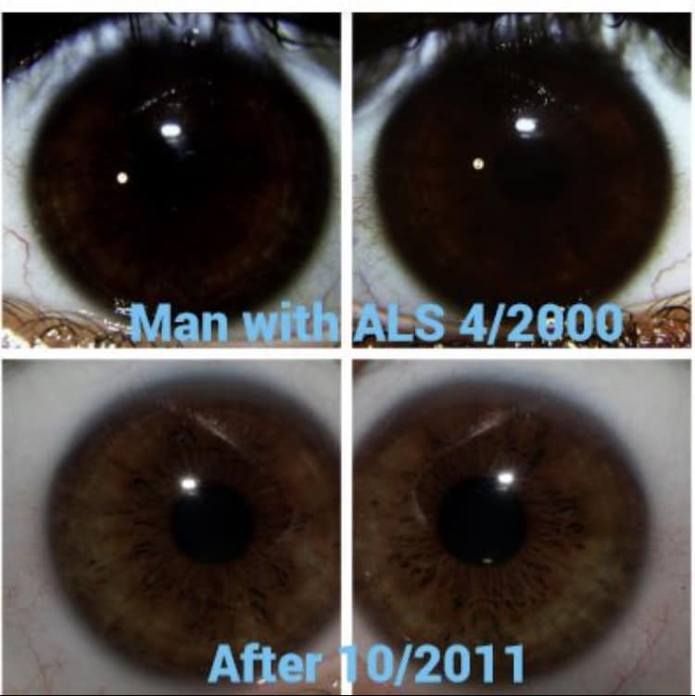

Aajonus about himself

Aajonus healing from 4 incurable diseases

“I eliminated my blood and bone cancers, my arthritis, diabetes and 3 other incurable diseases by daily ingesting raw dairy products.”

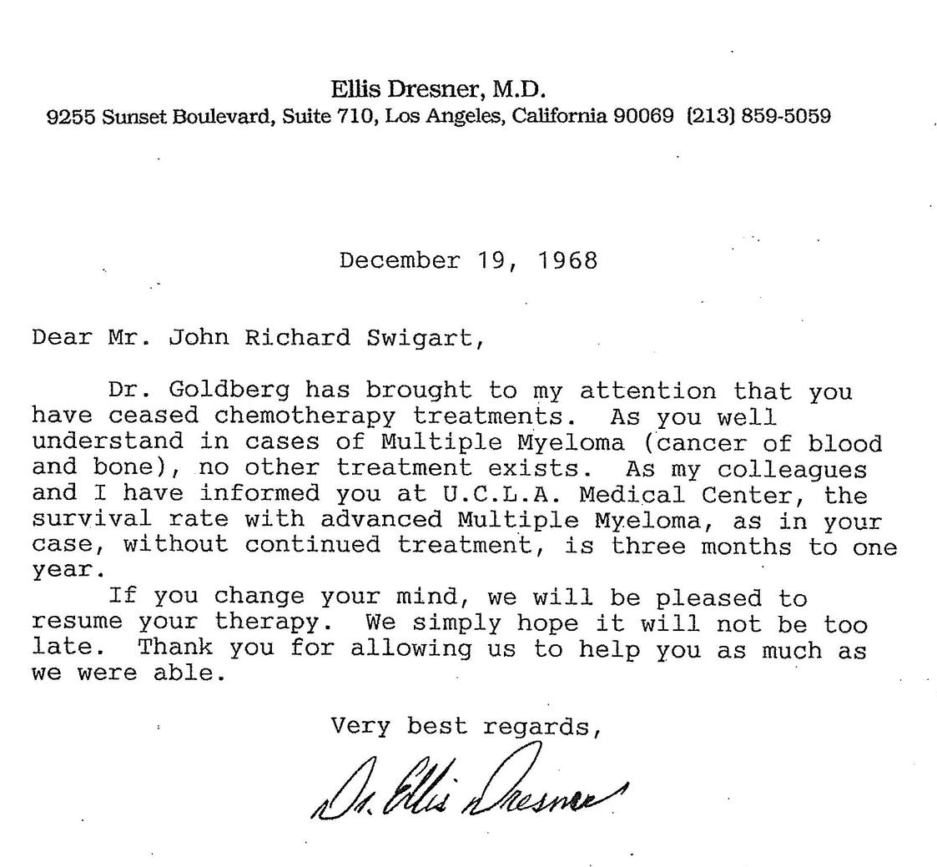

How aajonus survived the death cap mushroom poisoning

“In my 35 year I misidentified a poisonous mushroom and ate it. It was the deadliest amanita mushroom, the 'death cap'. I ate enough to kill people my size. My cancers returned twice as bad as they had ever been, and it destroyed 90% of my liver. Along with severe liver-pain, extreme weight loss. and body cramps, my diabetes returned. Every book on the death cap mushroom said that death came within 10 days and it was welcomed. No one in written history had survived after eating 1/15 the amount I had. I was a semi-invalid again. I healed slowly by eating plenty of raw fat. Too slowly. After 11/2 years of healing I began eating meats almost daily, including beef, lamb, buffalo, seafood and organically grown fowl. Healing time doubled and diabetes vanished. But it took me 61/2 years to recover to a somewhat balanced state of being and my cancers to reenter remission for the third time. It took 11 years to recover to where I had been before I consumed the poisonous mushroom. But I recovered completely.”
https://healthfully.ai/interview/bass?pos=8860&keywords=death%20cap

Aajonus healing his broken bone

Q: Yes, anything to help with generating bone? I have your bone growth formula.
A: Does everybody know what the bone growth hormone stimulator is?
Q: No
A: It’s pineapple, like I say in the book, to help heal and regenerate bones. Pineapple. Pineapple helps. I don't know if you've ever seen under a microscope. Bones have a web system that grows out and then it fills in. Pineapple for some reason stimulates this. Pineapple - I had it every day. I had a cup of it every day, when I broke this leg, because I split that tibia in two and it was separated in the back and they wanted to go in and push it back together and pin it. Plus the tibia, the top of the tibia, looks like this and the top of the bottom of the femur sits on it like this. It broke off the top of the tibia and it jammed up in the femur. They said that there’s no way that the body can dissolve that and get rid of it and that they'd have to go in surgically, go in and cut here to here, open up the leg and do all the surgery and I said "shit if I do that, that’s gonna take me five or seven years to heal just from your surgery, you know" I can eat pineapple...
Q: [Laughing]
A: … and they thought, 'this guy is crazy'. I was walking; I said, 'listen, if I can’t walk in six weeks I'll be back for your services”. I was walking without crutches within six and a half weeks. So it works. So eat pineapple cheese and honey together. Any of those things. Cheese and honey together in the mouth helps digest all the minerals and the fats and the proteins in the cheese. Cheese when it’s raw will not digest. The body will always use it. In every lab test I've done with any kind of animal, I've given them raw cheese. It passes out the feces with toxins attached to it - which is good! That’s what we want. Okay, if you’re eating cooked cheese, pasteurized cheese it’s all fractionated anyway so it just attaches the poisons and stays in your body instead of coming out. Now to get the cheese to digest... I've racked my brain; honey is a digestive enzyme, a mainly digestive enzyme because when the bee collects the nectar, the bee swallows the nectar, predigests it. It creates an insulin-like substance which converts the sugar to carbohydrates into enzyme structures to digest mainly protein and fats. So when you’re eating honey that's unheated above ninety three degrees - when it’s not heated above ninety three degrees - it has all of those insulin-like substances available for digesting whatever food you are mixing with it. If you lack good digestive enzymes, bacteria or the acids in your stomach, honey will help any kind of digestion. So when you have the honey, eating it after the cheese, or before the cheese and still it comes out in the feces. When you mix the cheese together in your mouth or mix it...mash it together or make it into a cheese cake fill with the honey that’s directly mixed into the cheese, it digests. So that’s where you get your mineral supplement. That’s where you get your highest calcium, magnesium, phosphorus, potassium. All of that to strengthen and take care of the bones. If you’re taking a mineral supplement that is clay or anything else thatis rock, you are not a plant. Plants eat rock. We are not plants. We don't spend our lives in a pot, in the dirt absorbing minerals because it takes a phenomenal amount of energy to eat rock and to make it into a bioactive form like the plants do. We are mobile individuals. We need everything already in a stage that can make us react instantly and that’s mainly meats and dairy and eggs. That’s our main diet and if we’re too alkalinized, it’s like the gorillas will chew a few leaves spit out the pulp and there they have some green juice.
https://healthfully.ai/qa/2007_11_18?pos=51598&keywords=feces%20toxins

Aajonus’ great stamina

A: I cherish all enjoyments of embodiment. My greatest pleasure is sexual sensuality. - It is the highest measure of bodily euphoria, the best feeling. - It is a balance for the routines of society that often lack pleasure. - When I was under stress, which is rare for my state of excellent health now, it released tension.
When I was a vegan/fruitarian, ejaculatory orgasm was pleasurable but draining. I got depressed, anxious and irritable if had regular ejaculations. I have always had a high level of sex hormones and have always since age 3 craved orgasm. My sexual appetite did not change on any diet that I tried. On a raw vegan/fruitarian diet I became more sexually frustrated.
Now that I consume so much raw protein and fat, I enjoy sex 1-6 hours, have up to 3 ejaculations, and maintain energy with only 5-6 hours sleep daily. I feel like I have finally achieved and chosen heaven on Earth.
https://healthfully.ai/interview/bass?pos=24149&keywords=sex%20heaven

Aajonus looking lean despite being high body-fat

And right now I’m up to 26% percent body fat. Now 26% body fat for the average individual, nobody here is that big, I was just in Florida I was standing up there and I lost about two pounds since I was in Florida last weekend. There was this guy that was this rotund that was sitting in a chair. And I said I’m 27% body fat and he says I’m 26% body fat. And I said I’ve been living on raw fats since 1974, my fat molecules are very tiny and concentrated. When you cook a fat, any food with fat in it it’s like taking a kernel of corn and popping it. It swells 10 to 50 times it’s normal size. So I’m a real fatty but I don’t look it. But that’s a good protective fat, my fat is concentrated.
https://healthfully.ai/qa/2007_02_18?pos=33787&keywords=26%20body%20fat

Aajonus sleeping 1h30 per day for 22 days while working hard on a difficult court case, which he won

“One time I went I slept an hour and a half a day for 22 days and only 10 minutes at a time. I was fine once I started back to my regular routine I didn't sleep any more than my regular 3 ½ to 4 hours a day at that time. And that was working day and night, day and night preparing for a trial against the government - another one. So many. So after you have your cheese again then after that you have your vegetable juice or your meat meal. You have your vegetable juice you're going to have to wait for at least 45 minutes to have your meat meal after that from the first time. At least 45 minutes. So I say after you have your vegetable Juice after you finish it 15 - 20 minutes later you have a cube of cheese. 10 minutes after that another cube of cheese - I mean 20 minutes after that another cube of cheese, and then 10 minutes after that your meat meal. So you’ve gone 50 minutes after you finished your vegetable juice to have your meat meal. If you go right into your meat meal you can go about 20 to 25 minutes after you finish the meat meal you have one or two cubes of cheese. 10 to 15 minutes after that you want to have cheese and honey together.”
https://healthfully.ai/qa/2013_06_22?pos=199956&keywords=slept%20court

Aajonus could have regrown his appendix

“Now, with me – I had my appendix removed at 15 ½, within days after my third polio vaccine. It gave me diabetes and angina pectoris. And I had my appendix out when I was 12 ½ after my first polio vaccine. And in that one they misdiagnosed it as an appendicitis and took out the appendix, so I had no appendix. However, my body has developed: either it has regrown my appendix – which I don’t know if it has – or I’ve developed another way for that library memory. Because last year, right after the house in Thailand was built, I had my down pillows and sheets in a box. And I took it out of the box – it had been sitting outside around the jungle waiting for the house to be finished, so I can have a bed and my pillows – and it was time – so I had the bed I was pulling out the pillows and I grabbed one like this and I felt a sting on my arm. And I pulled the pillow away and there was this tiny scorpion – this big. And the baby scorpions – the tiny scorpions – are the deadly ones because as the scorpion gets older it dilutes the venom, but the babies have a pure solid venom that’s not diluted. So, the heaviness went down the arm – you know, it got a rash and inflamed a bit – and all the way down – I could feel it moving all the way down to here. And it was about, probably 40 hours – 36 to 40 hours – I experienced that and then it went away. Then five days later I put some gloves on to work and one stung me here – again a little bitty one. And that lasted about an hour. Then three days later I got stung again. So, now I shake my shirts out; and I shake socks out; I don’t get into the bed unless I’ve checked for scorpions first. But, that one didn’t last 10 minutes – the last one – so my body has found another way, or it grew another appendix – I don’t know.”
https://healthfully.ai/qa/2012_05_27?pos=60915&keywords=grew%20appendix

Aajonus’ parents acknowledging him

Q: My family thinks I am a nut.
It was 25 years that I did the things I did before my father said I am proud of you. You are incredible. You do not age. You get younger. And all I am doing is getting more feeble. I just do not know how you do it from where you have been. And it was just within the last 8 years that my father acknowledged that. Hey, you can not please people. You got to please you and your own health. The best thing you could do is say you mentioned the tribes the Maasai and you mentioned the Inuit - the Eskimos. Before white man came around they had no degenerative diseases and they lived on raw meat. They had no cauldrons to cook with before white man came. They ate 99 % raw meat. The Maasai - before the white man introduced toxic foods to them - ate nothing but animal matter. No vegetables at all - ever. No fruits at all - ever. They were the healthiest, strongest, most athletic people in the world; now they are skinny and getting sick. They were the tallest, strongest, fastest race there was. Let me also give you a story. My father and mother retired to an island, Jekyll Island, Georgia. And on this island all the in group had a party. Each couple would have a party for all the other couples. There are only 8,000 residents and 90% of those were workers from the hotels at the golf courses. It is the land of golf courses. The few well-to-do couples had parties. There were 1-2 parties a month thrown by these couples. I happened to be in town when my mother and father were throwing theirs. And my mother invited me to the ball room for the banquet. And she said what do you want. And I said what are you serving. She said roast beef and fillet of sole. I said I would have the fillet of sole raw. My father slammed on the brakes to the car and said you are not going to embarrass me. You are not going to do that to me. I said, “ Dad this is 1981. I said people eat sashimi. People eat sushi. It is okay.” He said, “you are not going to embarrass me”. I said, “Dad it is my body. I know what feels good and what helps me. I am not going to tell you what to eat if I invite you to my party. So please let me have mine.” I am eating this and my father is mumbling under his breath. And their priest that they had invited said, “oh you are having sashimi.” Then others chimed in saying oh you are having sushi. And then my father just relaxed. You just have to go through these things. It is part of people growing into you if you are thinking about exploring this particular avenue towards health. It is in a program that is out there especially with the bacteria and parasitic phobia that is out there which has no basis what so ever. It is a whole theory.
https://healthfully.ai/qa/1999_01_24?pos=37906&keywords=age%20younger

Aajonus’ iridology changes

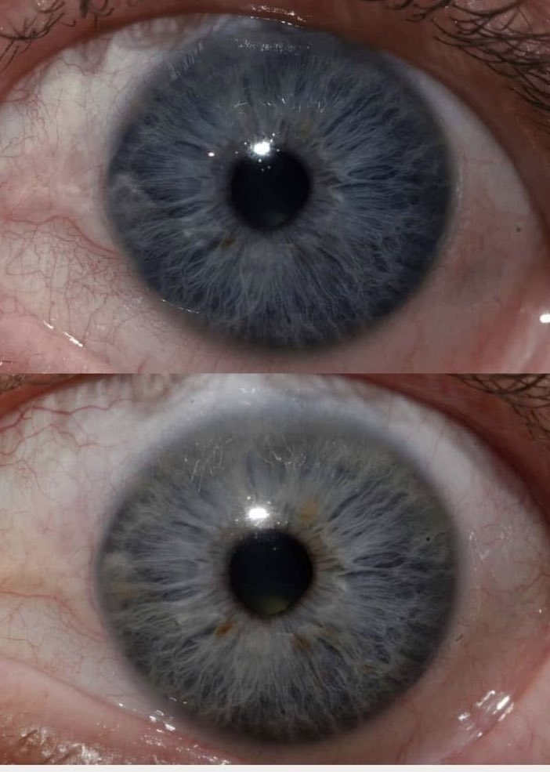
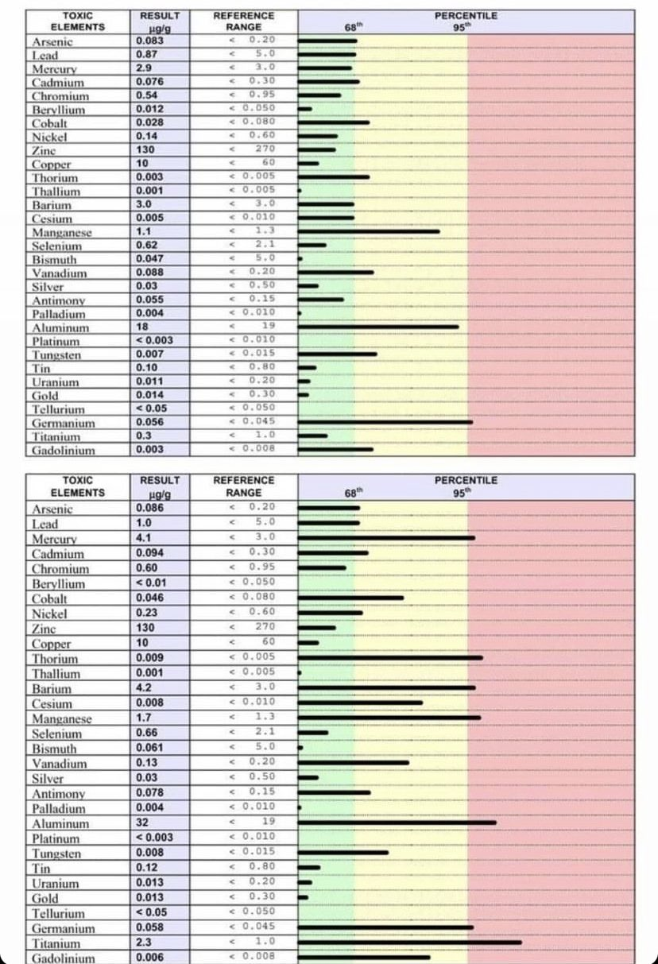
Aajonus' iris and hair analysis before and after being abducted and getting three forced vaccinations, during the swine flu vaccination campaign that he was a vocal opponent of.

Aajonus about tribesmen that he met

Tribes having superior health

I have visited tribes and I have visited communities all over the world that had NO vaccines. Their degree of health is astronomical. I have a farm in the Philippines - way out in the jungles -, away from civilization - nothing but tribes out there- and I hired anybody from 20 years old to 50 years old - to dig these fish-ponds which are 60' X 30' X22’ deep. They dig them by hand. They take these pails; they fill the pails then they pitch them up. So you get all this network of people. I had two of them (fish-ponds) dug, plus a swimming pool. These people would work 10 hours a day without a hitch - no problem. When I was at my grandparents' farm, when I was a child - you would see these 50 year old men throwing thirty, fifty, sixty pound bales of hay 15 feet up into a loft. Now, people are using fork-lifts because they can't do it any more. We don't have the strength So, you have to take a look at why...and it is mainly vaccines.
One of those tribes' individuals had been living in the city and had got vaccines. He was the only employee that did not work consistently and hard. So, he got the easy jobs and yet he was buff, taller-than-normal (than the other) Asians that were working for me. yet, he would go off and do all kinds of things - do anything to avoid hard labor.
https://healthfully.ai/qa/2013_06_22?pos=5915&keywords=tribe

Tribe with 138 years old life expectancy

I've met people who were 138 years old at a particular tribe in the Philippines and they had all of their teeth and they were incredibly healthy. They didn't look over 60 years old at 138. That is pretty frickin' phenomenal! Can you imagine having all your teeth at 55? (laughs) And no cavities! Pretty spectacular!
https://healthfully.ai/qa/2013_06_22?pos=78280&keywords=tribe%20philippines

Now one time I met in the Phillipines a tribe that live to an average of 138 years old. They lived on two foods, coconut and fish. Coconut and fish.
https://healthfully.ai/qa/2013_06_16?pos=85604&keywords=tribe%20fish

Aajonus also spoke of the African tribes Samburu, Fulani, Maasai, who also used to list past the hundreds, eat mostly raw animal foods, and for some of them could even run at world record speeds after eating high meat.

Aajonus’ scientific experiments

“The problem with Mercola is he is a think tank man with little varied experience and not a scientist.”
— Aajonus

Aajonus tried to publish his experiments, but scientific journals refused, for his “lack of credentials”.
The laboratory that Aajonus rented to perform his own experiments eventually claimed his work, preventing him legally from publishing them in detail.

The frozen food experiment

A: Go back to those tests I did with dogs and cats. When I fed them frozen organic meat, I got a whole side, split it in a quarter and I took sections of each and put them in two different categories and I froze one category. Every part of the animal. And I froze one quarter of the animal and then another quarter of the beef I did not freeze. I fed it to these animals for 6 weeks and some of them even up to 10. After 6 weeks every one of them had a skin disorder, who ate it frozen. Plus they were drinking, two to three, four cups of water a day. The dogs and cats that ate the meat non frozen, same meat unfrozen, even slightly getting stinky by the time at the end, at the end of the experiment, they rarely licked any water and they were in perfect health. Calm and happy. Other dogs were scratching, the cats were scratching and one even had mange from it. And it showed me that frozen meat is toxic. So not a good thing to eat. Now I knew that butter remedies any skin condition. And I had this argument with a lot of these people who think they know something and never go into a freakin' laboratory. Sally Fallons one of them, says “oh, freezing doesn't hurt your meat or hurt your dairy” so I took these animals and I fed them from the same batch of butter, frozen butter and unfrozen butter. The animals, the sick groups, they split them into two and I sent the frozen butter to one group and the other to the other. Those who got the frozen butter took five times longer to heal their skin condition. Five times longer!! If you break that down into a statistic, that's 80% of the nutrients were destroyed. Or unutilizable, whatever that was.
https://healthfully.ai/qa/2013_06_16?pos=69820&keywords=lab%20frozen

The parasite feeding experiment

A: In the laboratory tests i did with animals, feeding them meats that were infested with various parasites, none of them got infested with parasites, not one of them.
https://healthfully.ai/qa/2010_04_04?pos=58552&keywords=parasite%20animal

Q: So you’re saying there’s no risk in eating raw meat and getting a parasite?
A: That is absolutely fiction. After thirteen years having worried about getting a parasite or a brain fluke that would make me an idiot again, because I was autistic, I said to myself - I’ve eaten all kinds of parasite infested tissue and never gotten a parasite. So then I said, let me go see whose backing this information that says we get parasites from eating raw meat. Not one university has ever done one laboratory experiment. I have. Not one of the animals, even though they were sickly animals, that I fed parasite-infested tissue to, and I also ate them, none of us ever got a parasite. So as far as I’m concerned it’s all fiction.
https://healthfully.ai/qa/2009_09_13?pos=76413&keywords=parasite%20experiment

The parasite healing experiment

In the animal test that I did, the animals who had parasites got very well. The other animals that we gave a dewormer and we dewormed, they stayed lethargic. And when we performed autopsies at their death, these were all very old animals.
https://healthfully.ai/qa/2006_09_10?pos=68047&keywords=animal%20parasite%20experiment

The spontaneous fruit fly experiment

Q: My question after you heat at 300 degrees for x number of minutes where does any life appear from? A: It could appear extemporaneously. Q: It could just come out of nothing kind of like fruit flies. A: From what I understand about a fruit fly, they are spontaneously part of fruit for some reason because you can hermetically seal that and have the fruit contained in an isolation chamber and never exposed to any insects and all of a sudden the fruit flies will appear. So that to me is like the worms and the parasites. They are natural and indigenous to the fruit tissue just like parasites and bacteria are indigenous to animal tissue. But the crows and vultures are not but they will come and feed on it.
https://healthfully.ai/book/the_food_book?pos=156565&keywords=experiment%20fruit%20flies

The digestive fluids experiment

“I did in autopsies – I put the hydrochloric acid from the stomachs of 32 cadavers and I put it on different foods to see what it would break down – it did not but barely etch vegetables and fruit. When I put the hydrochloric acid on meat it went right into it. Put it on nuts, it barely etched. Softer nuts it helped a little bit, but not a lot. Only on dairy products and meat and eggs did it react almost completely and thoroughly. It’s the same with the human bile from the liver and gallbladder. I put that on different fats: vegetable oils, coconut cream, butter, dairy cream – it all worked almost 100% on those – on the animal products – on the animal cells, but hardly worked at all on vegetation – vegetable fat. We maybe get 2% of vegetables and that’s mainly juice. So, juice your vegetables.”
https://healthfully.ai/qa/2012_05_27?pos=70545&keywords=etch%20vegetable

Aajonus’ microscope observations of raw and processed nutrients

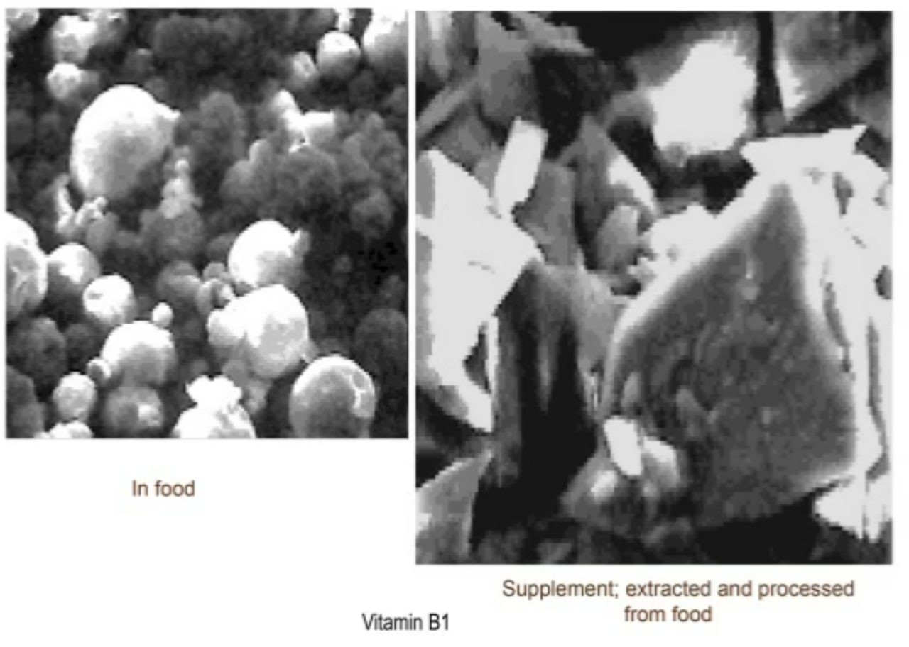
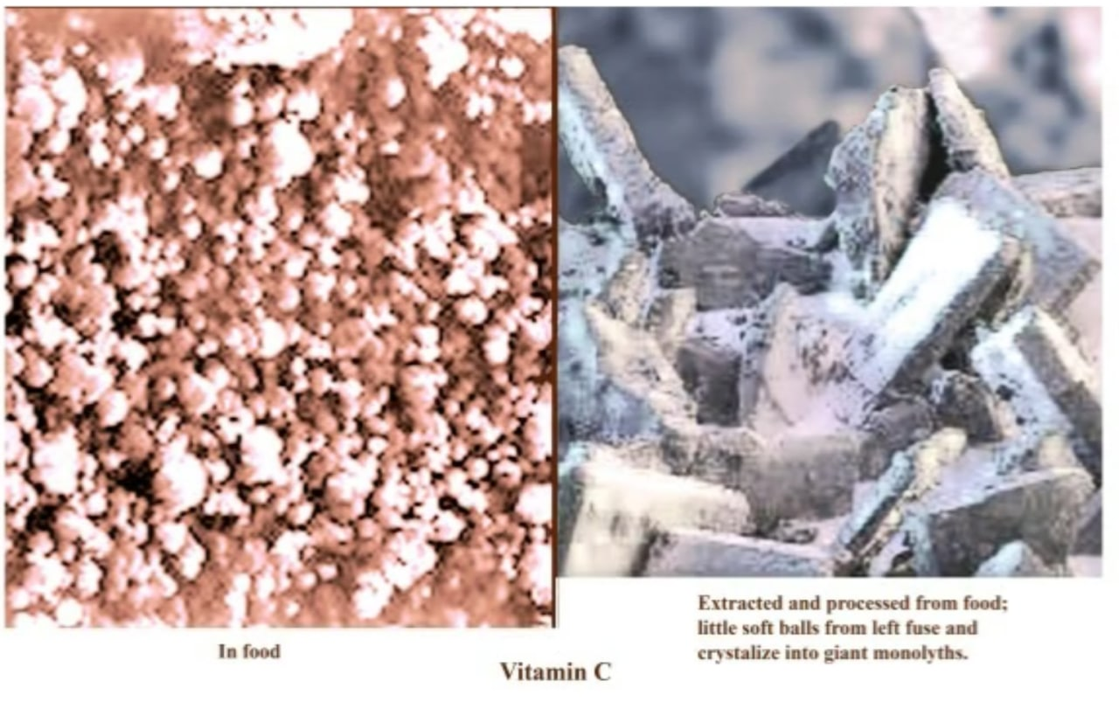

Eating raw fats to remove toxins

Q: Now how does eating fat remove toxins?
A: Well, we know that if we analyze fat in any person's body, we find great concentrations of toxins in the brain, in the bone marrow, and any fatty tissues on the body. And persons, they have fatty tissue in their muscles and around their body. If they're not overweight, then the poisons are going to go to the brain and bone marrow mainly. With that I knew that eating fats would bind with toxins. The body would use fat to eliminate toxicity in the system and bind with it. And I proved that in experiments and tests.
Q: Why don't you tell me about those.
A: I would feed animals toxic substances with and without…that was in food. I wouldn't purposefully poison them right off. I would take foods from a regular supermarket like meats that had hormones and other toxins injected into them for growth and for so-called immunity. I would find that if the group that I fed only the meats, a lot of that toxicity remained in their bodies that I analyzed in that meat that I was feeding them. And in the animals that I fed either butter or some cream or cheese along with the meats discarded most of those toxins out the feces.
Q: Now how did you know the first group was retaining the toxins.
A: Because it wasn't in their feces. It wasn't in their urine.
Q: And how did you check that?
A: I had the feces analyzed.
Q: Really?
A: Yes.
Q: What kind of toxins were there in the ones that were coming out?
A: Well, they had high rates of aluminum, barium, mercury, some had a lot of lead. There were a lot of synthetic hormones that were discharged. Growth hormones. Each analysis as the time cost me about $2,600. Now it's $8,800 to $12,000 per test. But that was back in the '80s when I did them.
Q: What I don't understand stand is we have toxins that are distributed throughout our body, right, because they get past the intestinal wall into the bloodstream or whatever. So how does consuming fat in your mouth that's in your digestive tract pull out those toxins from the body?
A: It doesn't pull them out necessarily. Well, cheese will. But what happens is the body's wise. Your white blood cells are fatty cells basically. That's why they call them white blood cells, because they're predominantly fat cells. And they consume toxicity. They're phagocytes. Phago means "to eat," and they eat toxicity. They consume it. So that is fat. Also, your body uses fat molecules to attract and bind or capture toxins and hold them.
Q: Okay, but that's in the body. That's not in the intestinal tract coming out the feces.
A: But see, if the fat goes in with the meat and the body has enough fat in the intestines with the meat while it's digesting it, then the body can arrest it right there. It doesn't have to get absorbed and then have to remove it with other fat later.
Q: I see. So eating fat doesn't necessarily reduce the bodily burden; it just ensures that any toxins in the food that you're eating get passed out.
A: Well, mostly. It doesn't do that in every circumstance with all kinds of toxins but most.
Q: So how do you remove the bodily burden of toxins.
A: LOL. Loooooonnnnggg process. Cheese will act as an attractor.
https://healthfully.ai/interview/joanne?pos=12749&keywords=feces%20toxins

Raw fats in contaminated foods preventing toxins from being digested

A: From laboratory analysis that I arranged with a technician on feces from raw meat eaters who ate supermarket quality red meat, tests showed that the same concentrations of toxins that were found in the fat of the meat passed out in the feces with the fat molecules relatively unchanged. These tests were done 9 years ago. I do not know if these same results could occur with present-day concentrations of chemicals and processed animal meals being fed to animals. I eat antibiotic-free and hormone-free red meat whenever I can, usually Coleman meat that I purchase at health food stores. When traveling to some locations I eat supermarket red meat. I have not had any ill reaction to supermarket red meat. I eat tremendous amounts of raw fat to bind with toxins and eliminate them from the body: that is one of the major functions of fats in our polluted society. I only eat poultry that is raised antibiotic free and free range. I do not eat farmed fish.
https://healthfully.ai/interview/bass?pos=35210&keywords=feces%20toxins

Raw unsalted cheese

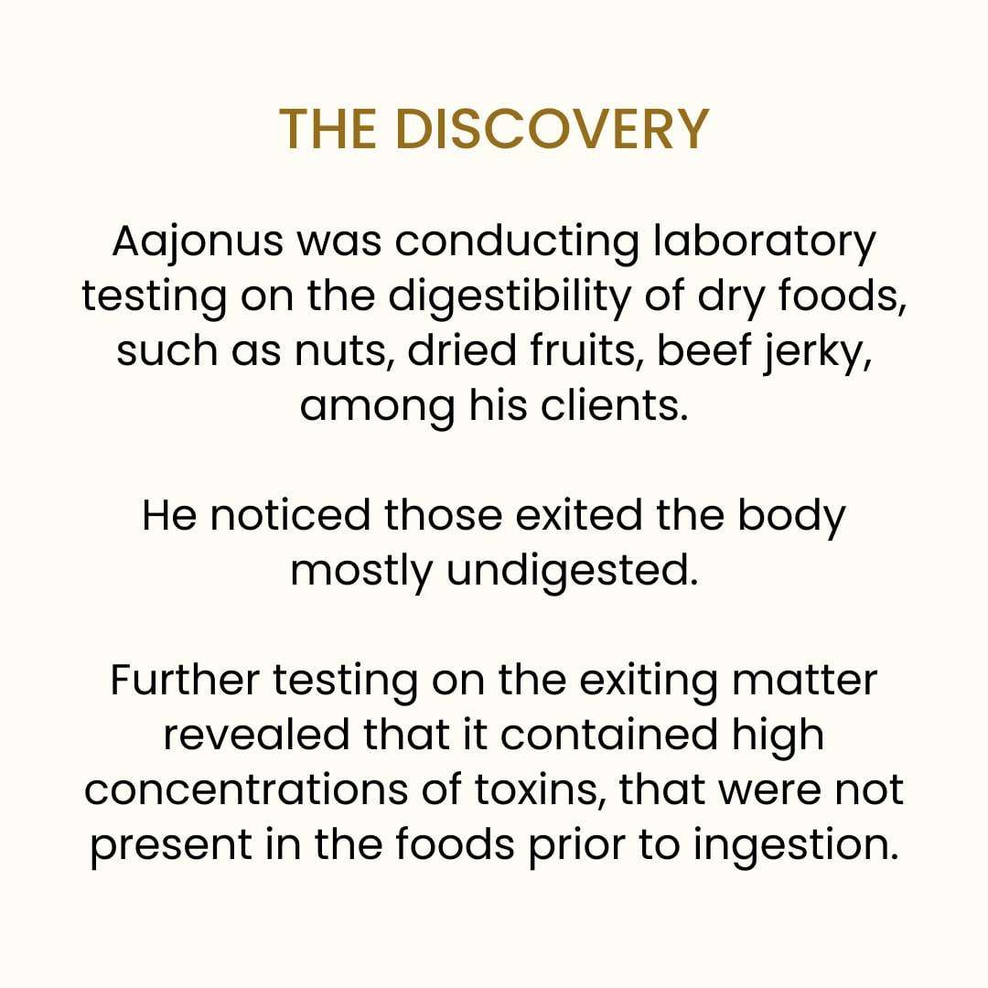
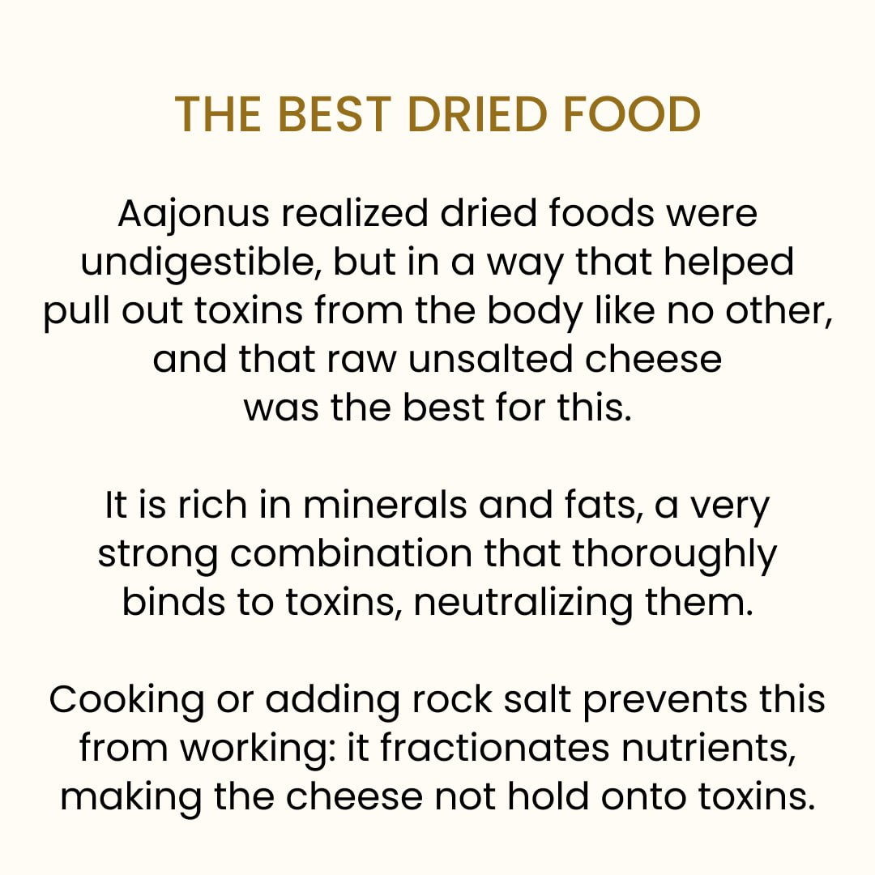

Moldy berry juice

From We Want To Live:

“While I was experimenting with raw moldy foods as possible remedies for particular health problems, Owanza, who was assisting me, discovered that eating moldy berries affected the mutant antibodies caused by vaccines. She placed raspberries, blackberries and strawberries in separate glass containers with lids that were not tight.
She allowed them to sit at room temperature until a healthy mold had formed. Then she placed them, still in glass containers with loose lids, in refrigeration for ten weeks. After these ten weeks, Owanza strained the moldy berries through a porous sieve, separately. The mold-juices were ready for my subjects.
Blood analyses were done on eleven people with long histories of vaccinations, with specific focus on amino acids. All subjects had minor complaints, ranging from headaches to joint pains. For one time only, each person drank ½ cup of one kind of mold-juice - of the particular berry that normally appealed to their taste. Their diets were not altered. Blood analyses were done 30 days after drinking mold-juice. Analyses showed an average of 30% increase in stable amino acids over previous analyses. There was only one side effect as a result of drinking the mold-juice - everybody became lethargic for a period of 0 days. After that period, everyone’s level of energy and health increased sharply above what it had been before drinking the mold-juice. Health complaints either diminished or disappeared.
Between 13 and 18 months after they drank the mold-juice, three of the people planned to get vaccinations for travel reasons. Blood analyses were done before inoculations and again a month after inoculations. The post-inoculation analyses showed a 30% drop in stable amino acids.
Twenty-four months after taking the mold-juice all eleven had blood analyses. In eight of them the stable proteins in their blood remained high. In the three who had recent vaccinations, stable proteins were still down and the health complaints that they had prior to drinking moldy juice returned.”

Scientific Studies

Pathogens

From the Recipe For Living Without Disease:

The microscience that studies “pathogens” is relatively new (50 years) and flawed. Newer research (20 years) has been and is being performed, proving that “pathogens” are responsible for the reversal of cancer, and possibly for cancer prevention. As part of her doctoral studies at the University of Toronto, Canada, Dr. Sara Arab injected verotoxin, a bacterial byproduct from E. coli, directly into human malignant brain tumors. After a single injection, the verotoxin completely dissolved both the tumors and their blood vessels within 2-7 days.26 Dr. K. Brooks Lowe of Yale University reported that researchers used salmonella to reverse cancer.
Many universities in Canada have been developing cancer treatment using viruses to penetrate cancer cells and dissolve them for decades. Many tests have been successful. Oncologist Don Morris at Calgary's Tom Baker Cancer Centre said, "It's common to hear that cancer patients who pick up a virus get a regression of their disease." Several of the universities that have jumped on the viral bandwagon are Havensack Medical School in New Jersey, Stanford is using the common cold virus, Harvard is using a herpes virus, Duke University is using a weakened polio virus, Mayo Clinic is using a measles virus. The projected retail price of an injection to the patient will be $8,000.
I suggest that we get colds or flu, eat high meat regularly and pay nothing.

Parasites are the most feared of “pathogens”. Parasites, too, have a symbiotic relationship with our bodies. They consume and digest tremendous quantities of degenerative tissue in short periods. Joel Weinstock, a gastroenterologist who heads a research team at the University of Iowa stated that we are the first population to be without gut worms. He asked six patients with very painful, intractable inflammatory bowel disease to drink the eggs of Trichurissuis, a whipworm parasite normally found in the intestines of pigs. Within two weeks, five of the six patients entered remission for up to five months. The patients begged for more parasites. Weinstock noted that intestinal problems are increasing in animals because they are kept too clean. Pigs and monkeys raised in sterile pens and cages are getting diseased.

Raw vs Cooked

